Hypothesis for each question:

1. Are arrests in Bronx and Brooklyn proportional to their populations?
   1. H0: Arrests in the Bronx and Brooklyn are proportional to their populations
   2. H1: Arrests in the Bronx and Brooklyn are not proportional to their populations
2. Are there more arrests on Federal holidays?
   1. H0: There is no difference in the number of arrests on federal holidays and non-federal holidays
   2. H1: There is a difference in the number of arrests on federal holidays and non-federal holidays
3. Is there an association between gender and race (Black vs. Asian) in the population of Queens?
   1. H0: Sex and race (Black/Asian) are independent. The proportion of males and females is the same across the racial groups.
   2. H1: Sex and race (Black/Asian) are dependent. The proportion of males and females differs across the racial groups.
4. Are arrests in Bronx and Brooklyn proportional to their populations?
   1. H0: Arrests in the Bronx and Brooklyn are proportional to their populations
   2. H1: Arrests in the Bronx and Brooklyn are not proportional to their populations

Test run: Chi-squared test

Assumptions:

1. Data is categorical:
   1. Chi-squared is for categorical data
   2. The Boroughs are categories, and the number of arrests and population are counts
2. The observations must be independent
   1. Each arrest should be independent of others. An arrest in Brooklyn should not influence an arrest in the Bronx
   2. Due to the nature of the data c
3. Counts should be sufficiently large
   1. The expected frequency for each category should be at least 5 to ensure that the Chi-squared approximation is valid.
   2. Expected arrests were much larger than 5 (63997 for Brooklyn and 33895 for Bronx)
4. The data is a Random Sample
   1. The arrest data covered the entirety of both boroughs so as not to be biased in collection.
5. No More Than 20% of Expected Frequencies Should Be Less Than 5
   1. 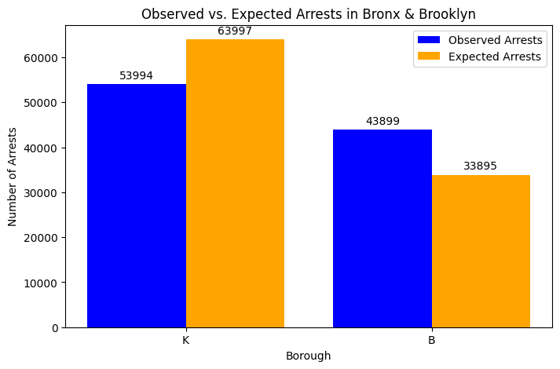There are only two categories (Brooklyn and Bronx) both are above 5

Alpha = .05

Chi-Square Statistic: 4515.636750396534

P-value: 0.0

P < alpha so reject the null hypothesis: Arrests are NOT proportional to population.

1. Are there more arrests on Federal holidays?
   1. H0: There is no difference in the number of arrests on federal holidays and non-federal holidays
   2. H1: There is a difference in the number of arrests on federal holidays and non-federal holidays

Test run: Two sample t-test

Assumptions:

1. The samples from Federal holidays and non-holidays are independent of each other. Arrests on consecutive days did not influence each other. The holidays are completely different days, and there were no repeated days
2. Both groups (holiday and non-holiday arrest counts) are approximately normally distributed: